Generate Report

Click “Generate Report” link from menu to generate department report.

Select report name from list then report will automatically generate.

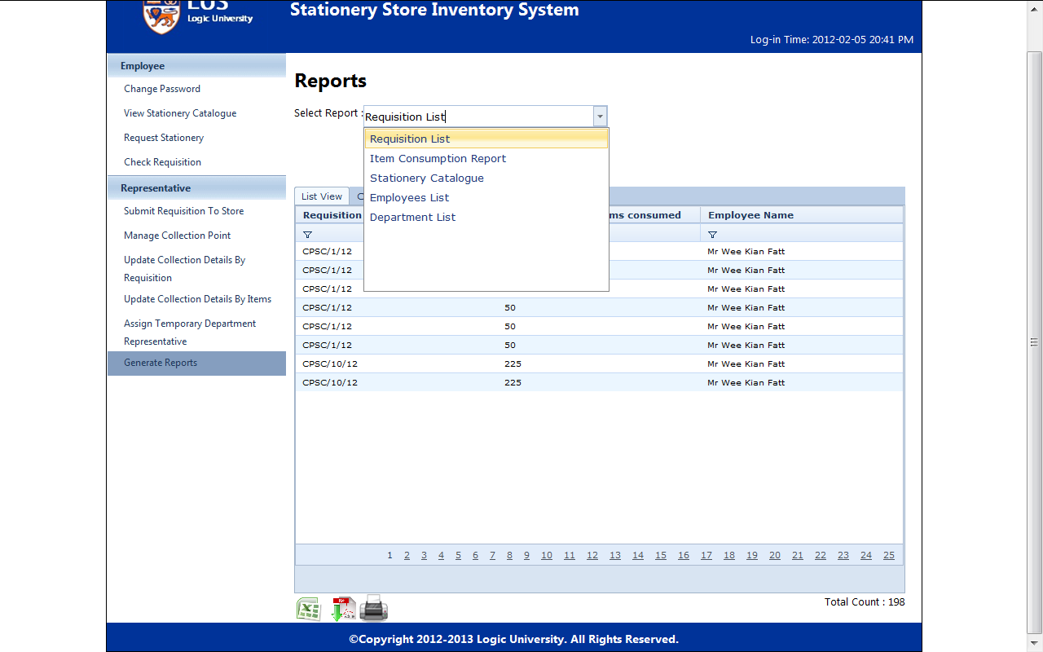

Requisition List

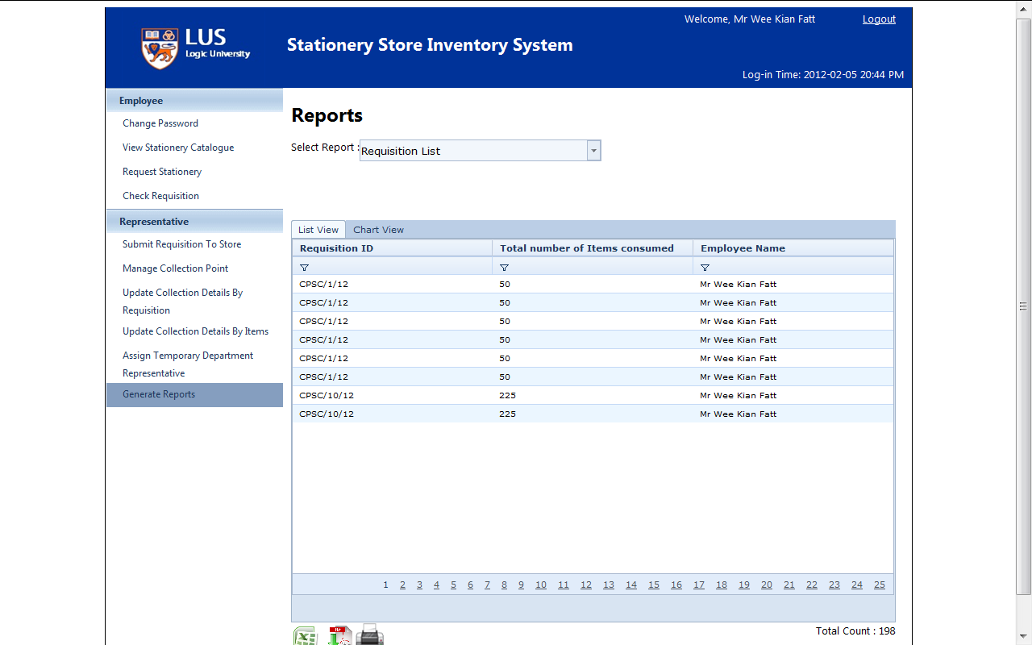

Item Consumption Report

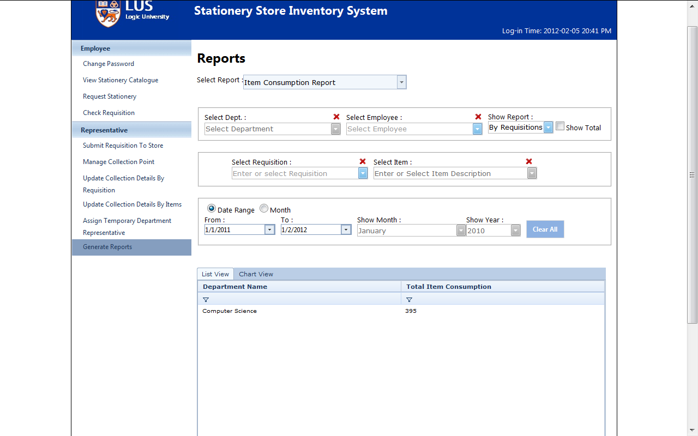

Stationery Catalogue

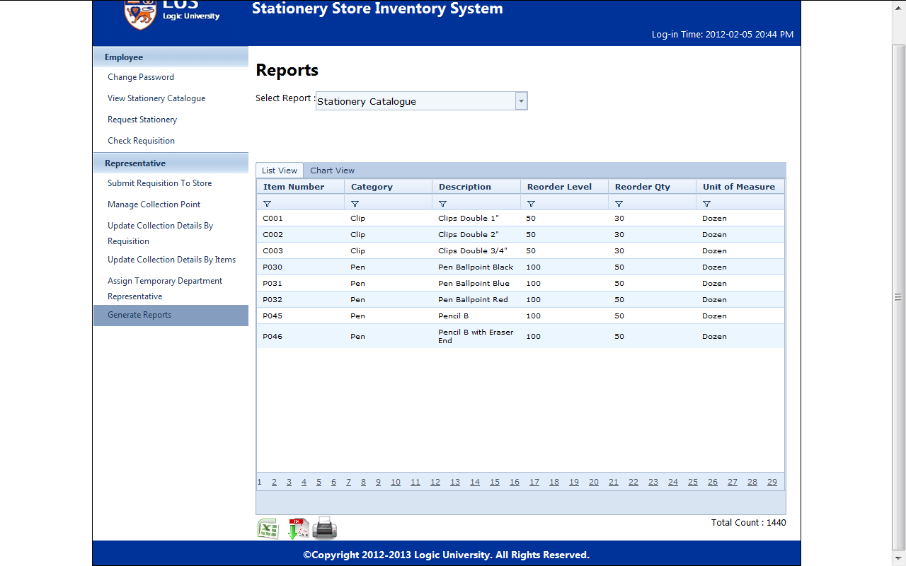

Employee List

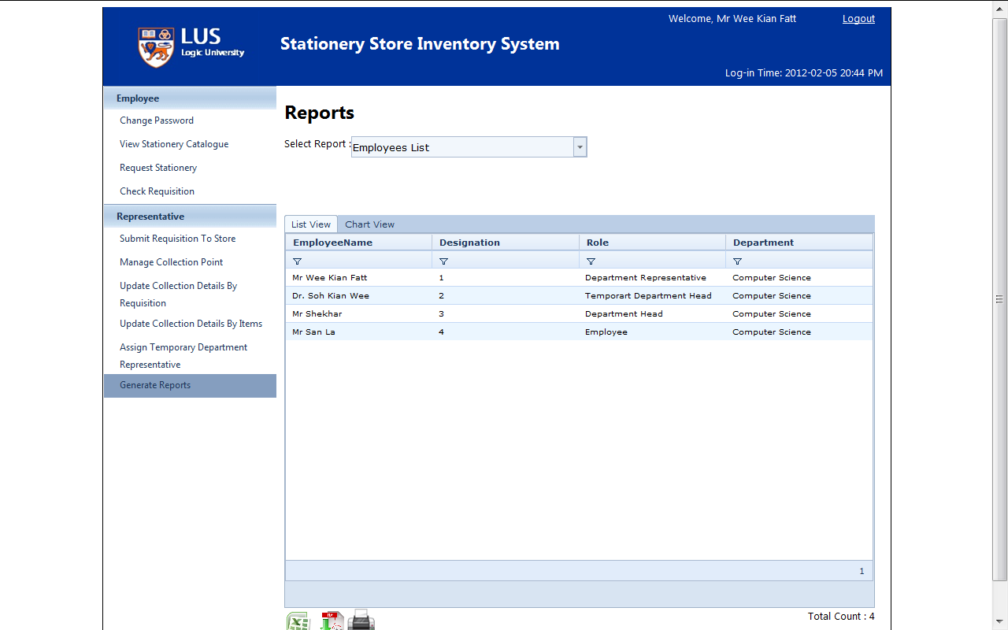

Click “Chart View” can view in chart instead of list

(s)